16 Channel RS485 Relay Manual
- 2CH RS485 Relay Serial HyperTerminal Enter(16-channel do not have AT command mode):
http://v.youku.com/v_show/id_XMTM0ODY4NzkxMg==.html
- 2CH RS485 Relay Modbus Poll Enter(Usage 2-channel and 16-channel is the same):
http://v.youku.com/v_show/id_XMTM0ODY4OTg5Mg==.html
Features:
1: DC 12V power supply.
2: Standby current (all relays closed) 12MA, 1 relay open 40MA, 2 relays open 67MA, 3 relays open 95MA,4 relays open 121MA,5 relays open 147MA,6 relays open 173MA, 7 relays open 198MA,8 relays open 223MA…
3: "open" "close" "Momentary" "Self-locking" "Interlock" "Delay" 6 Commands
4: MODBUS RTU command
5: Under the "Delay" command ,the maximum delay is 255 seconds
6 MODBUS commands can be made serial HyperTerminal (serial assistant) OR "Modbus Poll" Enter;
7 Under the MODBUS command mode, it can support up to 64 devices in parallel
8 Size: 168 * 65 * 19mm
9 Weight: 218 g
10 Maximum load: 10A / 250VAC, 10A / 125VAC, 10A / 30VDC, 10A / 28VDC, 10A / 12VDC
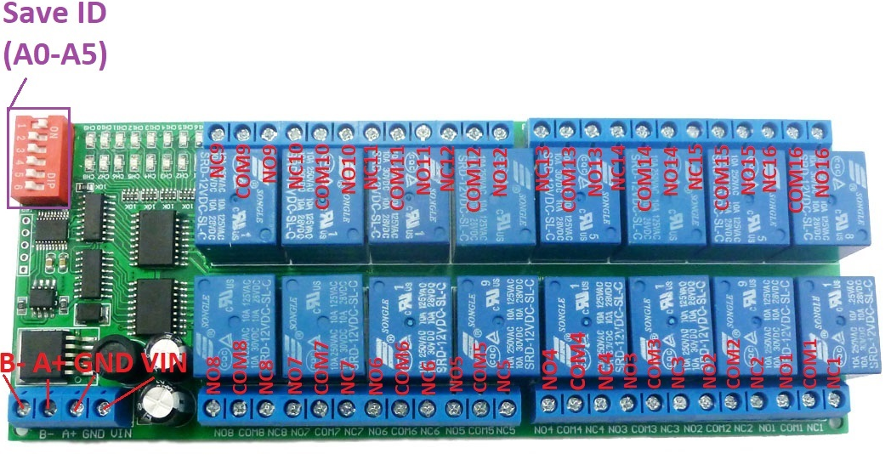

Glossary:
NO : Relay normally open contact
COM : Relay common contact
NC : Relay normally closed contact
Open : NO connection COM, NC disconnect COM
Close : NO disconnect COM, NC connection COM
Momentary : Enter the Momentary command, the Rreceiver Relay is Open, delay of 0.5 seconds after, Relay is Close;
Toggle : Enter the Toggle command, the Rreceiver Relay is Open, Enter the Toggle command again, Relay is Close;

Latched : Enter the Channel 1 Latched command, the receiver Channel 1 is Open, the Channel 2 is Close.
Enter the Channel 2 Latched command the receiver Channel 2 is Open, the Channel 1 is Close.
Enter the Channel 3 Latched command the receiver Channel 1 is Close, the Channel 2 is Close.

Delay : Enter the Delay command, the Rreceiver Relay is Open, delay of 0-9999 seconds(MODBUS command is 0-255 seconds )after, Relay is Close;
During the delay, Eter the Close command, immediately close the relay

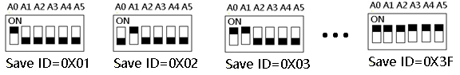
Slave ID: A0-A5 is the slave ID, you can choose 64 different slave ID.
Under the MODBUS command mode,the slave ID must be correct

command Description, Please refer to "16 Channel RS485 Relay Command"

Typical applications:
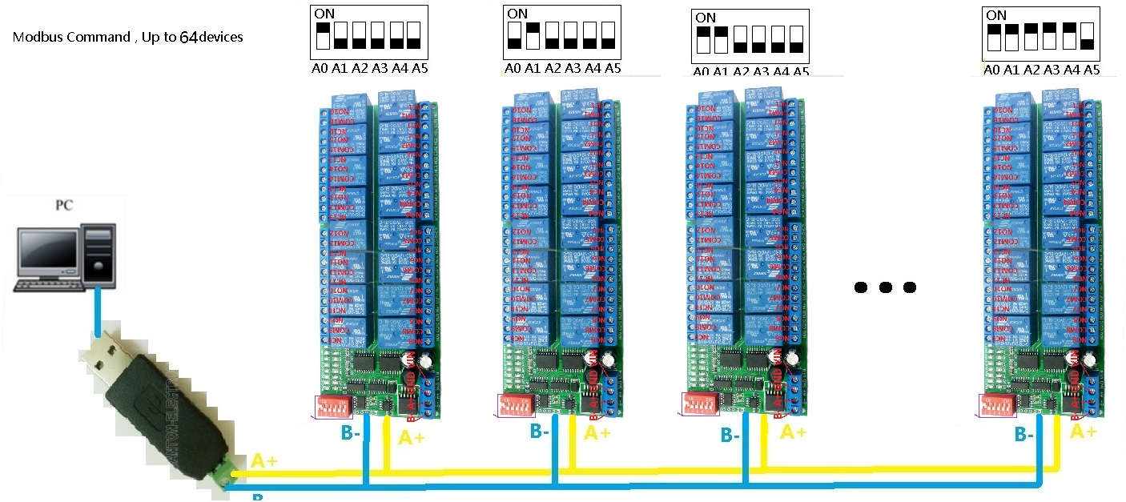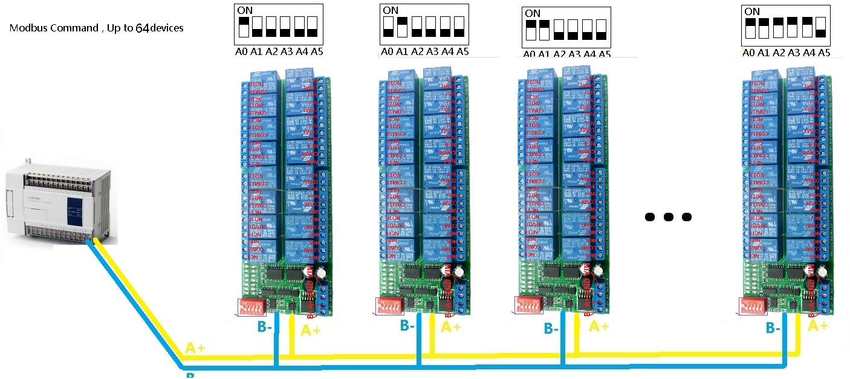

MODBUS command mode (HEX), you can control a variety of ways: Serial Hyper Terminal Control (need to manually add the CRC), Modbus Poll software control (software automatically add the CRC), PLC or MCU process control

Wiring Diagram:

1 DC 12V control circuit,Wiring diagram below. "LOAD" may be camera,LED lights, fans, motors and other DC 12V equipment
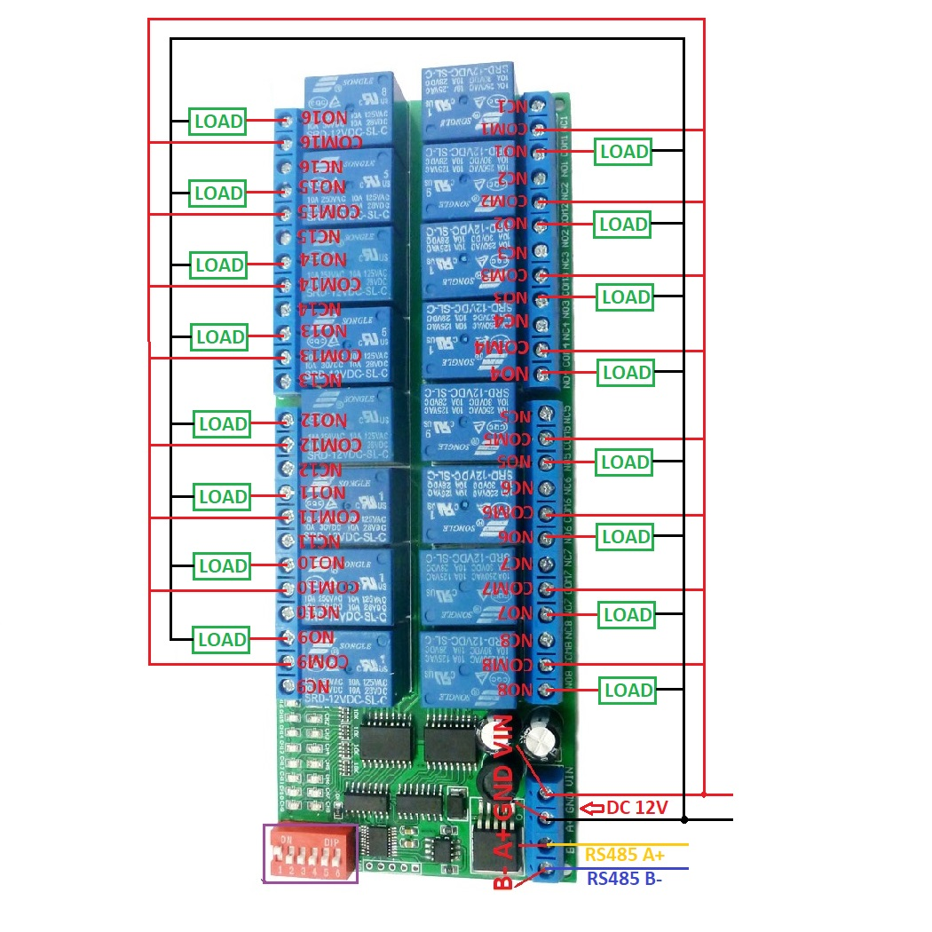

2 DC 1-100VAC 85-265V control circuit,Wiring diagram below(Note:If not DC 12V load, need another DC 12V power supply). "LOAD" may be LED lights, fans, motors Lights, fluorescent lights, solar water heaters and other DC AC equipment
