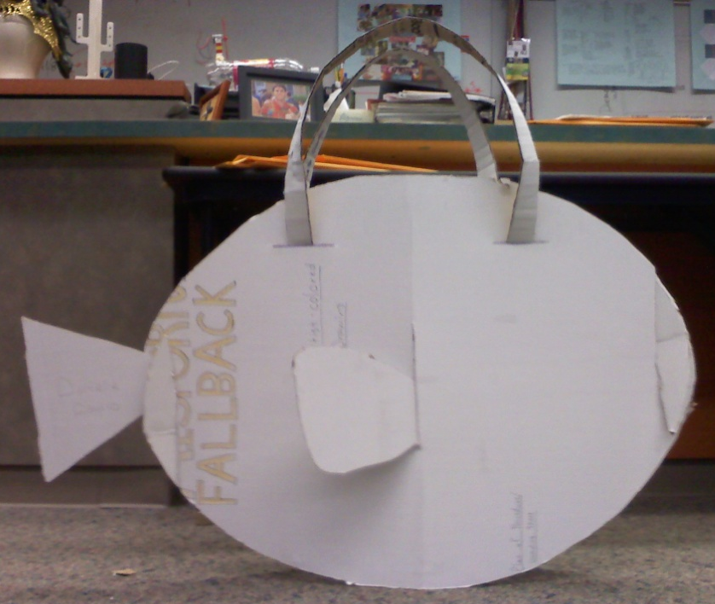
Plan of Procedures
Danielle C.
Finding Nemo: “Dory”

Supply list
ITEM | MATERIAL DESCRIPTION | QTY | SIZE | REMARKS - PART
S1 | CARDBOARD | 3-4 | 3’ x 2’ | Single-ply - has to be bendable. Will be used for the body, fins, and shoulder straps for the costume of the Finding Nemo character “Dory”

Tools and Equipment list
ITEM | TOOL | USE
TI | CUTTING MAT | To place the cardboard on when it’s cut so the floors aren’t ruined
T2 | UTILITY KNIFE | To cut the cardboard to the correct sizes and shapes
T3 | RULER | To measure the dimensions of the cardboard pieces
T4 | PENCIL | To mark the dimensions or outline the shapes of the pieces to be cut
T5 | CIRCLE TEMPLATE OR COMPASS | To create circular shapes
T6 | SHIP’S CURVE | To create irregular and unique shapes

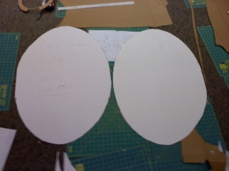
Steps for producing parts:

Part P1 (Dory’s Body):
1. Bend the ship’s curve (T6) to make one quarter of an oval.
2. Outline the shape of the body using the ship’s curve (T6) and a pencil (T4) on a 3’ x 2’ sheet of cardboard (S1). (The dimensions of the two oval body shapes should be 3’ x 2’)
3. Place the cardboard (S1) on a cutting mat (T1) and use a utility knife (T2) to cut the outline of Dory’s body.
4. When the oval is horizontal, go in toward the center 3” from each end and mark both with a pencil (T4).
5. Use the pencil (T4) to draw a vertical line upward from the first 3-inch mark. Then draw a vertical line downward from the second 3-inch mark. Use the utility knife (T2) to cut the cardboard (S1) along the lines.
6. Halfway between the edge and the second 3-inch mark/line draw a vertical, centered line the length of 4½ inches. Use the utility knife (T2) to cut along this line. (This is done on only one of the two oval body pieces!!)
7. Use the pencil (T4) to draw another vertical line, centered on the whole piece of cardboard (S1). The line should be 4 ¼ inches in length. Use the utility knife (T2) to cut along these lines on a mat (T1).
8. Between that horizontal center line and the edges of each costume piece, draw a horizontal line that’s 4 inches long. The line should be 4 inches down from the top edge of the body. Make the same line between the center line and the opposite edge of the body. Use the utility knife (T2) to cut along these lines. Do for both oval shapes.
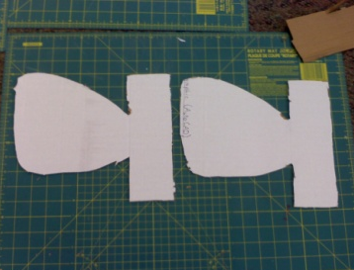
Part P2 (Dory’s Pectoral Fins):
1. Draw an 11 ¼ inches x 9 inches rectangle with the pencil (T4) from a piece of cardboard (S1).
2. From the base, go inward 3 inches, and then draw a line upward 3 inches. From the top, go in 3 inches and then draw a line down 3 inches. This should provide 3 inches between the two lines.
3. From the ends of the two 3-inch lines, create a fin the length of 7 ½ inches. Use a utility knife (T2) to cut the outline of the fin.
4. Do this again to create a second fin.

(One piece of 3’ x 2’ cardboard can be divided and used to make both P2 and P3)
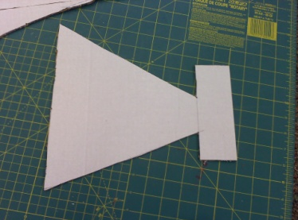
Part P3 (Dory’s Tail/Caudal Fin):
1. Draw a 1 ¾” x 6” rectangle. Erase 2 ¼” from the center of the rectangle’s side.
2. Make a vertical line that’s 10 ½ inches long. The line should be 8 ¼” from the rectangle and also be parallel to it.
3. Connect the ends of the two lines on the one rectangle side (that were separated into two because part of the line was erased) to the ends of the parallel line.
3. Use a utility knife (T2) to cut the outline of Dory’s tail fin.

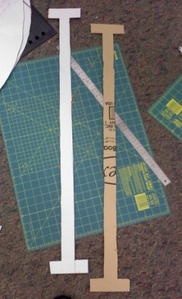
Part P4 (Shoulder Straps):
1. Use the utility knife (T2) to cut out a 4 ½” x 36” rectangle from the remaining cardboard (S1) on a mat (T1).
2. From the lower left corner of the rectangle, go up 1 ½” and use a pencil (T4) to draw a horizontal line across 1 ½”. Draw a vertical line upward 33”. Then draw a horizontal line 1 ½” back to the edge/side of the rectangle. Use a utility knife (T2) to cut out this outlined area on a mat (T1).
3. Do this again on the opposite side of the rectangle. The overall shape should somewhat resemble and uppercase “I”.
4. Cut out a second shape like this from another 4 ½” x 36” piece of cardboard (S1).

PART LIST
ITEM | QTY | PART NAME
P1 | 2 | DORY’S BODY
P2 | 2 | DORY’S PECTORAL FINS
P3 | 1 | DORY’S TAIL/CAUDAL FIN
P4 | 2 | SHOULDER STRAPS

Steps for Assembling Parts:

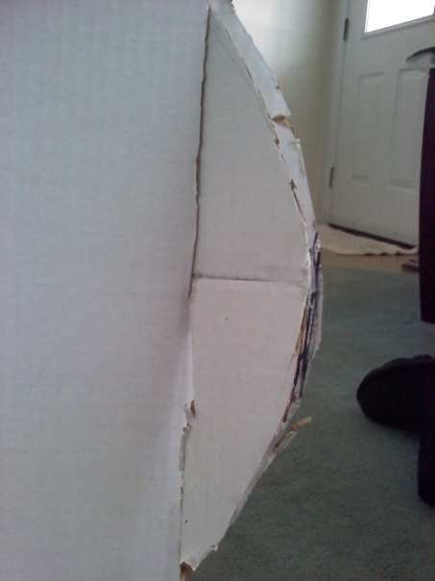
1. The two oval shapes that make up P1 should be slotted together. Do this by sliding the opposite slits into each other. The two ovals

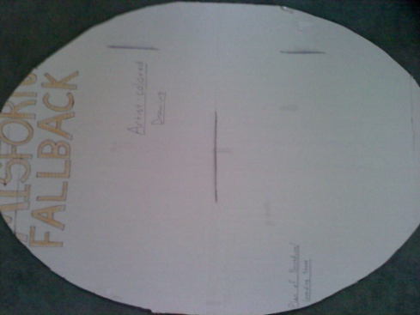
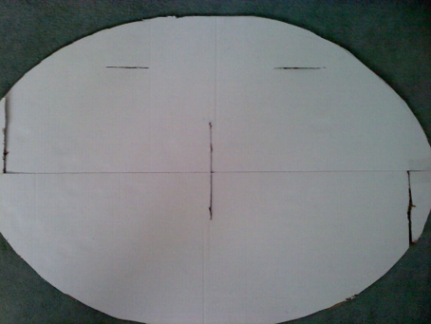

2. The tail fin (P3) slides into the slot between the edge of the body (P1) and the slot used to connect the two oval shapes of the body (P1). This slot was only done on one of the two ovals.
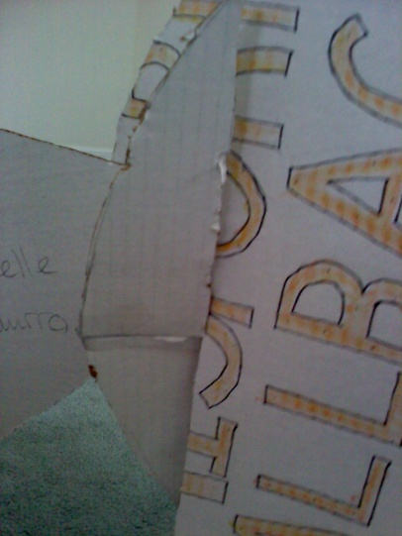
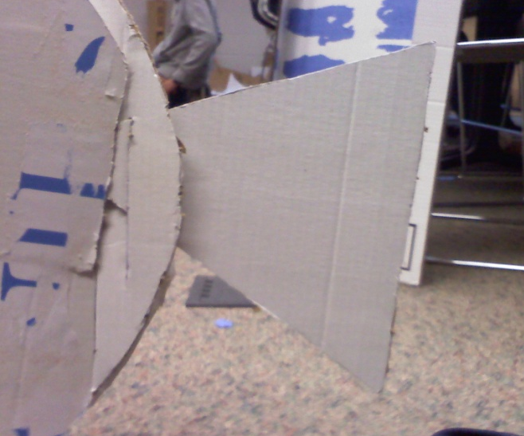
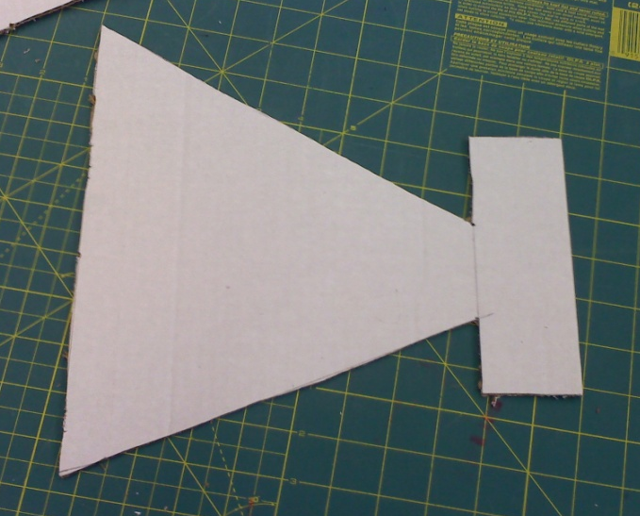

3. Each dorsal fin (P2) slots into the side of each oval on the vertical slots in the center.
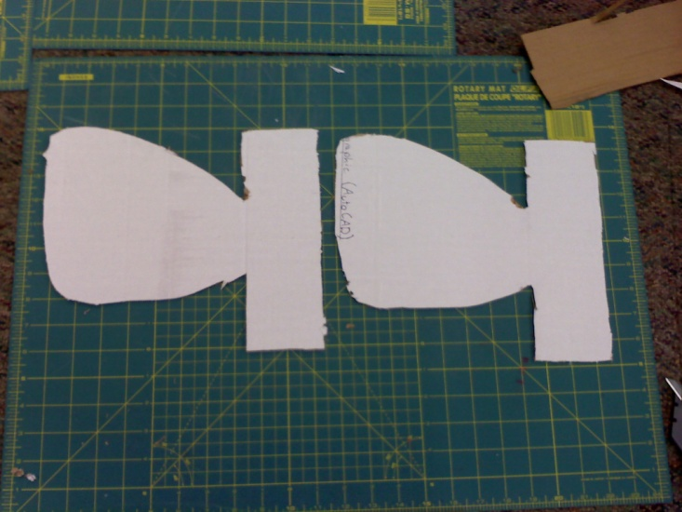
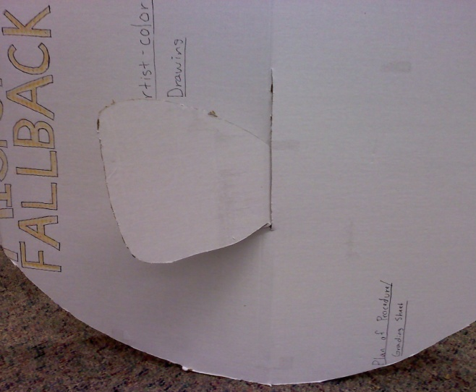

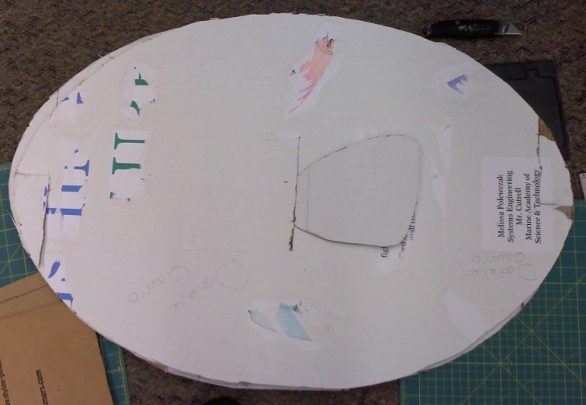
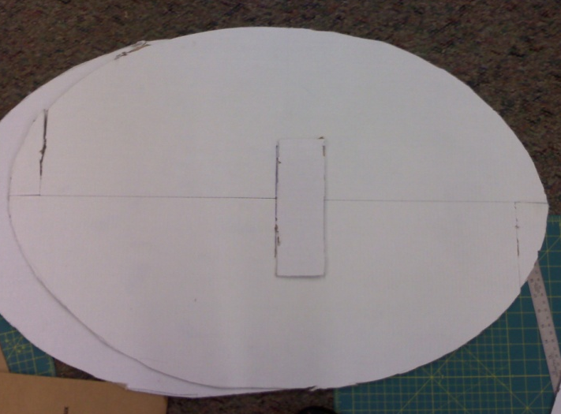

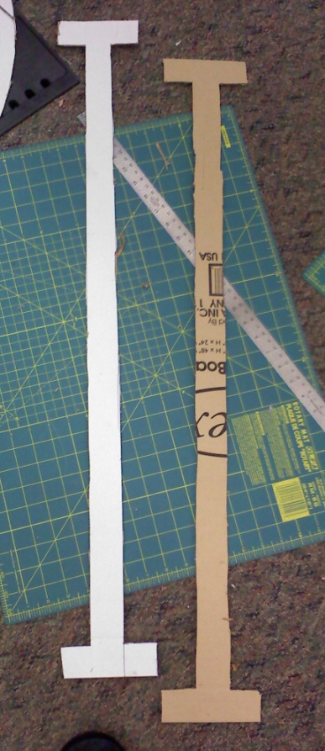
4. Each of the shoulder straps (P4) are slotted into the horizontal slots at the top of the body (P1).
