Final build showcase
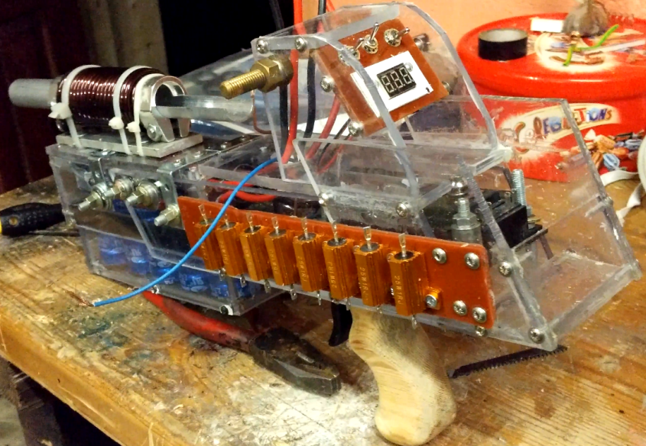
In this document is a showcase of the completed and working Coilgun, with the MKI coil since the newer coil was never fully mounted because of time constraints and broken parts.
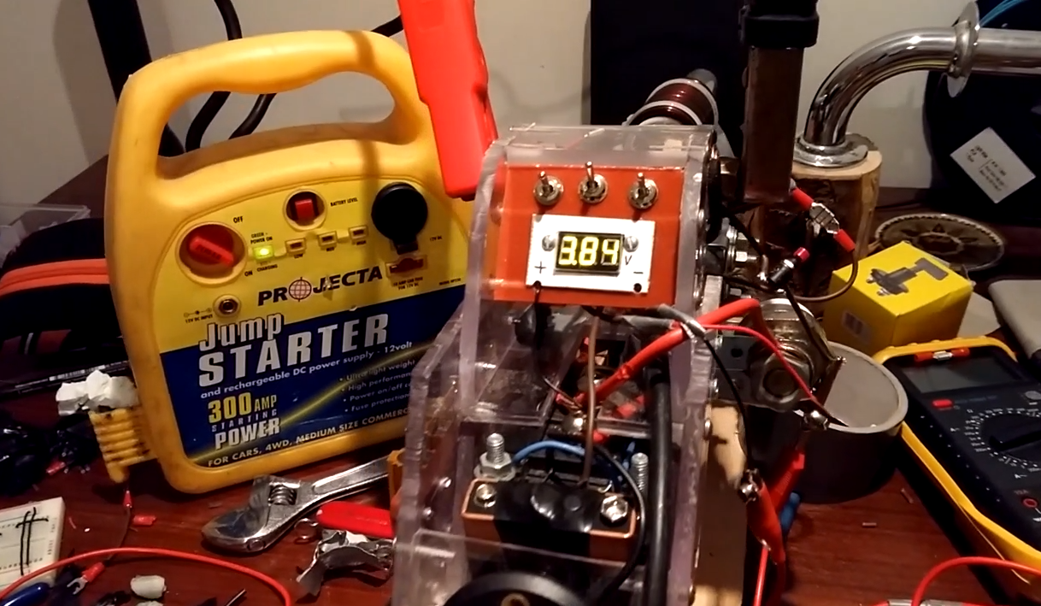
The housing of the Coilgun is constructed with thick polycarbonate sheeting, used for its tendency to warp but never shatter or break, making it ideal for this application in which it may receive short sharp bursts of recoil. The sheets are mostly joined with screws or bolts, and polyester resin glue. Some segments are joined together using large bolts exposed on the outside (notice the bolts on the side of the capacitor bank) which is to allow quick and easy access to enclosed parts. The coil is made with 5mm enamelled copper wire wound around an aluminium tube and mounted on a sheet of thick aluminium with bicycle seat posts and cable ties (although the cable ties were more of a temporary fix for what should ideally be welded together.). The handle was shaped from a block of hardwood to be ergonomic and easy to grip, and the trigger was designed in blender and 3D printed.
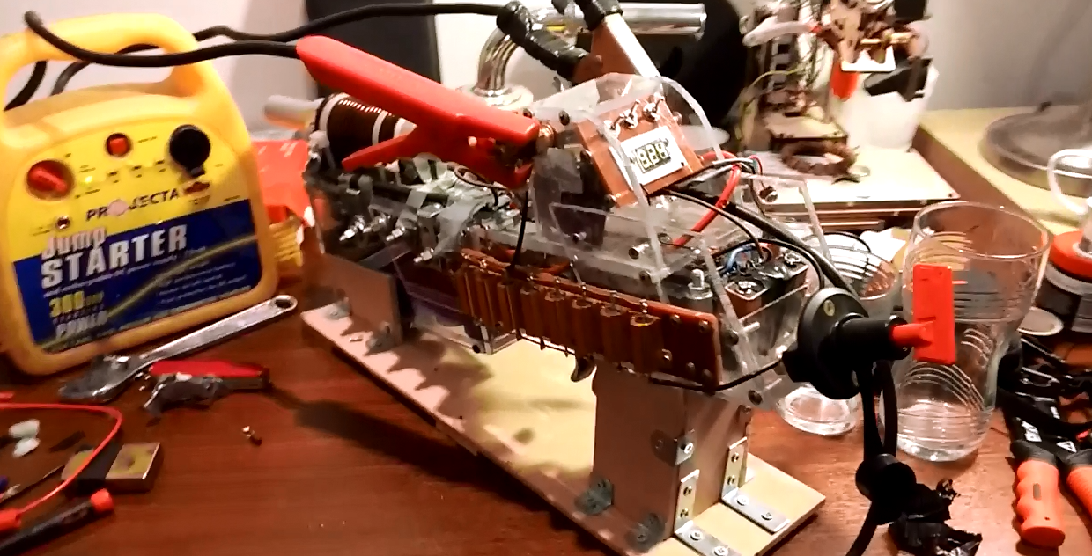
The Coilgun is charged using a 12V DC power supply, which makes the charging process very versitile because it can be charged using a number of different sources. These include jump starters, car batteries or anything else capable of supplying 12V DC. Above you can see how I have simply attatched the crocodile clips from the jump started to the brass bolts which protrude from either side of the housing. This charges up the capacitors and a small digital voltmeter displays the voltage. A challenging improvement to the coilgun would be to get the display to express the voltage as a percentage of 12V. The Coilgun also requires 2 9V batteries to run, although it would be fairly simple to redesign it to run exclusively on the capacitors. On the front control panel there are switches which have not been set up but are there to control the aiming laser mounted below the barrel, to switch the battery on and off to save you having to unplug it manually, and a final switch which was there so that if needed I could switch between an alternate mode which would use a timing circuit instead of an infrared detection circuit to switch the coil.
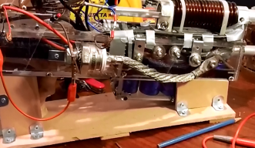
The positive terminal of the jump starter goes into the resistor array which allows the current to be considerably higher than with most charging circuits, allowing the capacitors to charge to 1200C in under 10 minutes. This is because the resistance is very low and the resistors can handle a large wattage, so although there are 8x 1Ω resistors the total resistance is just over 1Ω and the power is around 120W. I also have incorporated a lock which requires a specific key to be opened, for safety purposes and to more easily be able to control when the capacitors are allowed to be charging.
One of the most striking features is the large schottky diode mounted on the side of the Coilgun, whose function as a flyback diode is the allow the current causing to magnetic field to flow through only itself whilst the magnetic field collapses, preventing large voltages from damaging other components that cannot handle the high current. Although it is likely overkill, this does an excellent job of protecting the other components.

